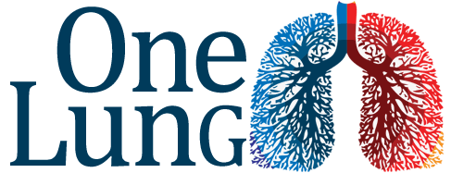
Thoracic Anaesthesia course at Royal London Sim Centre

- Develop your knowledge of one lung anaesthesia.
- Refresh your practical skills through training on skill stations and clinical scenarios.
- Practice using high-fidelity simulation environment.
- Excellent refresher for Consultants occasionally asked to provide lung isolation for trauma, spinal, vascular or upper gastrointestinal procedures.

Workshops Simulation
Double lumen tubes Four high quality scenarios
Bronchial blockers Experienced faculty
Clinical / bronchoscopic checks Non-technical skill feedback
Troubleshooting, tips and tricks
Suitable for Anaesthetic ST3+ & Consultants
RCoA approved for 5 CPD points
(CPD Matrix 1I03, 2A01, 2A06, 3A01, 3G00)

Friday May 17th 2019
Delegate registration £100 • Refreshments and lunch included
Booking: RLH_SIM_ADMIN@bartshealth.nhs.uk
